ANNEX 04 – USER REQUIREMENTS

The Bidder should provide the following in the specified order in Section 4 of the proposal/bid document.

Provide detail information of the proposed solution as per document enclosed. Please note that marking should be carried out in the following manner; The Remarks column should be used to explain or provide detail information.

DESCRIPTION | REMARKS
Rating - 5 | If the User requirement is met 100% as defined in the RFP without any work around method.
Rating - 4 | If the User requirement is met 75% as defined in the RFP without any work around method. Define the number of hours required for the modification and cost in US$ in the Remarks column, inorder to provide 100% functionality as defined.
Rating - 3 | If the User requirement is met 50% as defined in the RFP without any work around method. Define the number of hours required for the modification and cost in US$ in the Remarks column, inorder to provide 100% functionality as defined.
Rating - 2 | If the User requirement is met 25% as defined in the RFP without any work around method. Define the number of hours required for the modification and cost in US$ in the Remarks column, inorder to provide 100% functionality as defined.
Rating - 1 | If the User requirement is met as a Work around method defined in the RFP. Define the number of hours required for the modification and cost in US$ in the Remarks column, inorder to provide 100% functionality as defined.
Rating - 0 | If the User requirement is not met as a defined in the RFP and modifications are required. Define the number of hours required for the modification and costs in US$ in the Remarks column.

The NBL rating is as follows:
1 = critical ; 2 = essential; 3 = nice to have

USER REQUIREMENTS OF DELIVERY CHANNELS AREA : ELECTRONIC BANKING
Ref : | User requirements | NBL Priority | Bidder’s Rating | Bidder’s Remarks
0 | Security (Please provide details) |  | 5 | TEMENOS ARC has been developed to provide banks using T24.  State of the art Security is inherent in the ARC Internet Banking design. Features include:  - Multi-level firewalls  - Reverse Proxy server (optional)  - Configurable overall Servlet access restrictions  - Primary authentication system using validated third-party supplier  - HSM storage of cryptographic keys  - Encrypted authentication credentials  - Minimum code in Servlet Container/Web Server  - Application security between system components  - Third-party Penetration Testing (Ethical Hacking) during development  - Obfuscation in page source code  - No useful data in URLs.  - Specific measures against SQL injection, buffer overflow and cross-site scripting attacks  - Bank-defined inactivity timeout  - User lockout after incorrect login attempts  - T24 Security Management System for user rights  - A range of transaction authorization option  - Powerful transaction daily limits structure  - Risk attributes for beneficiaries with related limits  - Dual authorization for administrative changes
 | Systems Security (access levels) | 1 | 5 | Supported by T24. Please refer to response above.
 | Facility to set security policy (e.g. password lockout after three attempts) | 1 | 5 | Supported by T24. Please refer to above response No. 0.
 | Facility to administer user security from central location(from bank) | 1 | 5 | Supported by T24. Please refer to above response No. 0.
 | Support different access methods including User id & password, Tokens, Smart cards | 1 | 5 | Supported by T24. Please refer to above response No. 0.
 | Integration
 | Online integration with the Banking Systems as defined in the RFP. | 1 | 5 | Supported by T24. In fact, ARC-IB is using the same database with T24 and fully integrated, which support all online integration.
 | Online Integration with third party and custom applications | 1 | 5 | Banks increasingly want an integrated multi-channel environment in order to have a single view of the customer and for the customer to have a joined-up and consistent banking experience. This mitigate against interfacing a third-party internet banking system to T24 as virtually all have their own database resulting in a data silo. Furthermore, with an add-on system, when a bank needs to add additional STP functionality it is expensive and time to market is long for new financial products.
 | Features
 | Inquiry functions for designated account balances, deposit rates & exchange rates | 1 | 5 | ARC Internet Banking supports the full range of T24 enquiries. A range of model enquiries are provided with the system, but the bank can create as many as it wishes without the need for coding.  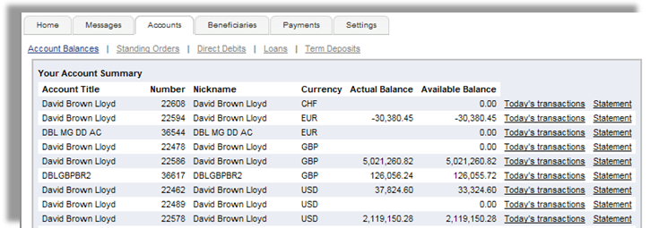  Figure 1. Account Balance Enquiry
 | Download of statements and interim statements | 1 | 5 | Customers can also view and print the transaction receipts. PDF documents can be downloaded by users from a document management or file system. This is done securely so that a user cannot hack a URL to get a document he is not entitled to.
 | LC applications and processing status updates | 1 | 5 | Supported by T24
 | Check book requests | 1 | 4 | Supported with some configuration and customization.
 | Funds transfers | 1 | 5 | Supported by T24.  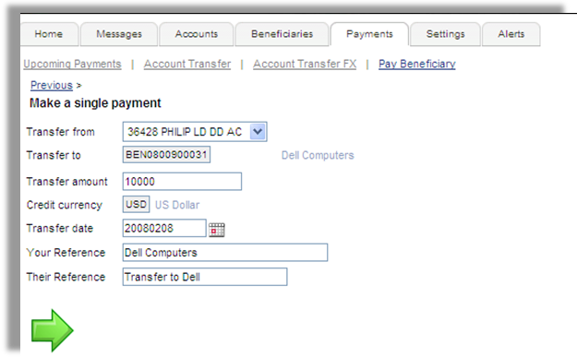  Figure 2. Funds Transfer Facility
 | E-mail mail support (secured internal system) | 1 | 5 | Options of requesting statements to send through fax, e-mail, and post are supported.
 | Third party payments (Multi currency) | 1 | 5 | Supported by T24.
 | Stop payments | 1 | 4 | Supported with some configuration and customization.
 | Upload of SLIPS payments (mass payments e.g.: company salary payments) | 1 | 5 | The functionality in R08 GA includes: File upload for payment instructions
 | Issued cheque status (paid, paid today, unpaid) | 1 | 5 | All enquiries related to cheque processing are supported.
 | Customized template creation to satisfy user requests | 1 | 3 | This can be supported through customization.
 | Account reconciliation facilitation | 1 | 5 | Supported by T24
 | Documentary credit & Guarantee transactions | 1 | 5 | Supported by T24
 | Information Ticker (Stock prices, Exchange rates, Business News, T bill rates) | 1 | 5 | Supported by T24. Customers can enquire on different exchange rates that are published by the bank.
 | Forward contract Booking & viewing outstanding forward contracts | 1 | 4 | Supported with some configuration and customization.
 | Limit Tree lookup (usage of Facilities granted) | 1 | 5 | Customers can view all their limits granted, utilized amount, available amount and percentage of utilization.
 | Technical Specifications
 | 24*7 uptime capability (please explain) | 1 | 5 | TEMENOS ARC has been developed to provide banks using T24 with a modern, scalable and fully integrated personal retail, corporate and private front office banking solution. ARC includes multi-channel access, OCRM, ACRM/Campaign Management and Process Workflow. All business functionality for ARC modules is within T24. This inherently provides a uniform user and administrator experience; all data stored in the same place, full real-time access, high availability and 24x7 operations.
 | Ability to automatically detect errors and fix them and send alerts to support staff via SMS / Pager. | 1 | 5 | NDB can market products by means of prompting promotional messages. NDB also has the option of prompting customer specific messages like birthday or anniversary greetings.  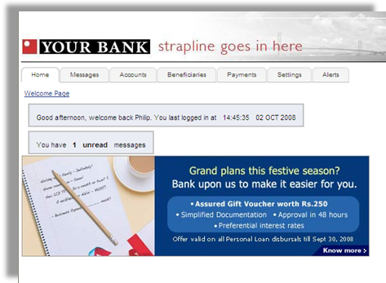  Figure 3. Promotional Message in ARC IB
 | Detailed description of how data integrity and recovery is maintained throughout the transaction. (How incomplete transactions are dealt with and if users are notified of successful transactions) | 1 | 5 | All the necessary data required for the internet banking service are captured and maintained.
 | Transaction tracking and alerts for unsuccessful & suspect transactions (alerts to be sent to support staff (definable using routing tables)) | 1 | 4 | Supported with some configuration and customization.
 | Detailed description on how the system can handle business growth, sudden increases in transaction volumes, what can cause performance bottlenecks, what should be done to avoid these issues. | 1 |  | This will be handled in a technical presentation.
 | Detailed report on any system limitation on growth including max no of users, max no concurrent users & any transaction limitations. Please give details of benchmark tests. | 1 |  | This will be handled in a technical presentation.
 | Detailed description of system architecture, is the system platform independent. | 1 |  | 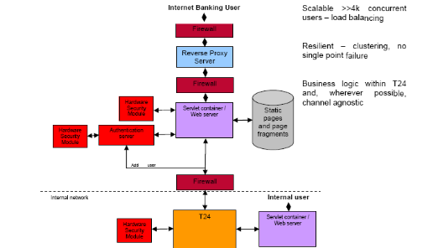  Figure 4. Architecture and system overview
 | User data input validation (e.g. date formats) | 1 | 5 | Supported by T24
 | Support multiple languages | 1 | 5 | The system supports up to 12 languages simultaneously. The system ignores browser language setting. ARC Internet Banking supports UTF-8 character sets and right-to-left orientation languages.
 | Demos for prospective users | 1
 | Facility to define priority users | 1
 | Facility to group users (for a group of companies) structure & access to be defined by use of custom tables | 1 | 5 | Supported by T24
 | Facility of Help functions for users and frequently asked questions | 1 | 5 | An area of the page contains context-sensitive ‘header’ text explaining what a user should do. Additionally, a hyperlink on every page brings up a help text window. Help is in the language of the user and the wording is defined by the bank.
 | Facility to monitor transactions to completion status (e.g. Pending for authorisation, Pending for processing) with time taken for each process | 1 | 5 | Supported using T24 Process Workflow module. The module will display processing status of each activity.
 | Automated backup & recovery functions. | 1 |  | This will be handled in a technical presentation.
 | Reports
 | Audit report of suspect transactions date & time, details of transaction. | 1 | 5 | A range of daily and ad-hoc reporting on user activity, exceptions etc can be configured according to a bank’s requirements.
 | Audit report for all changes to the system files and transactions to the system | 1 | 5 | A range of daily and ad-hoc reporting on user activity, exceptions etc can be configured according to a bank’s requirements.
 | Event journal with selective online searches by customer, amount, transaction amount, transaction type, transaction date and time. | 1 | 5 | A range of daily and ad-hoc reporting on user activity, exceptions etc can be configured according to a bank’s requirements.
 | Usage management Reports (what are the most frequently used features, who are the regular users, what are the heavy usage times) | 1 | 4 | A range of daily and ad-hoc reporting on user activity, exceptions etc can be configured according to a bank’s requirements.
 | Audit trail of all transactions performed, suspect transactions & rejected transactions Inclusive of customer name, transaction type, date, type of transaction, transaction no, details of transaction, & transaction amounts. | 1 | 4 | A range of daily and ad-hoc reporting on user activity, exceptions etc can be configured according to a bank’s requirements.

